
MIT Art, Design and Technology University
Rajbaug Campus, Loni-Kalbhor, Pune 412201

School Name :- MIT School OF COMPUTING
Name :- Ashish Phapale
Enrollment NO :- ADT24SOCBD210
Subject :- Full Stack Web Development
Subject Code:- 23IT3101
Academic Year :- 2025-26

Under the guidance of
Prof. Reetika kerketta

DEPARTMENT OF INFORMATION TECHNOLOGY

MIT School OF COMPUTING
MIT Art, Design and Technology University
Rajbaug Campus, Loni-Kalbhor, Pune 412201
2025-26
Sr. No. | Topic | Sub-Topic | Date | Sign
1 | Create a static Homepage layout using bootstrap.
 | 1.1 | Design a Responsive Homepage using bootstrap component like container etc.
 | 1.2 | Use the grid-system to create a structured and adaptive layout for web-app.
2 | Design a grid-based information page.
 | 2.1 | Develop a multi-column content layout using bootstrap grid.
 | 2.2 | Display items such as cards product review or blog entire with consistency.
3 | Setup a NodeJs project with Express Server.
 | 3.1 | Initialize a new Node.js project using npm init.
 | 3.2 | Install ExpressJS and Setup basic webserver with routes like Home,About etc.
4 | Implement Modular Routing and Middleware Logging
 | 4.1 | Organize server logic using separate route modules
 | 4.2 | Add middleware to log request URLs, methods, and timestamps for all incoming  traffic.
5 | Create a Data Submission Form and Handle POST Requests
 | 5.1 | Build an HTML form (e.g., for adding items or submitting feedback) and handle  its POST request using Express.
 | 5.2 | Display the submitted data dynamically on a confirmation view.
6 | Serve Dynamic Content Using Server-Side Rendering
 | 6.1 | Render a list of items (e.g., products, posts, services) dynamically using EJS  with hardcoded or temporary in-memory data.
 | 6.2 | Route should accept data from the server and render it in the view using loops.
7 | Create Dynamic Detail Pages Using URL Parameters
 | 7.1 | Use route parameters to render individual item details dynamically via EJS.
 | 7.2 | Display properties like title, description, and date using passed route data.
8 | Build a Reusable Layout Using EJS Partials
 | 8.1 | Create common EJS partials (header, footer, navbar) and include them across  views.
 | 8.2 | Maintain consistency across all pages by using a shared layout template.
9 | Connect Node.js to MySQL and Perform Basic CRUD
 | 9.1 | Create MySQL tables and connect to them using a MySQL Node.js package.
 | 9.2 | Implement basic CRUD operations from Express routes to the database.
10 | Develop RESTful APIs for Data Access and Manipulation
 | 10.1 | Build a set of RESTful APIs using Express.js for performing operations.
 | 10.2 | Test the endpoints using Postman and ensure they return structured JSON  responses.

Experiment No.: 1

Title: Create a Static Homepage Layout Using Bootstrap

Aim: To design and develop a responsive static homepage using Bootstrap components such as containers, jumbotron, headers, and buttons, applying the grid system for an adaptive layout suitable for any web application.

Objectives:
- To understand the structure and purpose of Bootstrap’s container and grid system.
- To apply Bootstrap components like jumbotron, headers, and buttons in a webpage layout.
- To design a responsive web page that adjusts to different screen sizes and devices.
- To develop a static homepage layout without using dynamic scripting or server-side technologies.

Theory:
Bootstrap is a front-end framework used for developing responsive and mobile-first websites. It is built on HTML, CSS, and JavaScript, and provides reusable design components that simplify web design.
Key concepts:
- Container: The fundamental layout element that centers and pads the content on the page.
- Grid System: Bootstrap uses a 12-column grid system allowing developers to structure the webpage into rows and columns for a consistent and responsive layout.
- Components: Predefined design elements like buttons, navigation bars, and jumbotrons help create visually appealing and functional interfaces quickly.
- Responsiveness: Bootstrap automatically adapts the layout to different screen sizes through its built-in media queries, ensuring a seamless user experience on mobile, tablet, and desktop devices.
By combining these features, developers can efficiently design web pages that maintain professional appearance and usability across various devices.
Conclusion:
Through this experiment, a static homepage was successfully created using Bootstrap’s grid system and UI components. The webpage layout automatically adjusted to different screen sizes, demonstrating the framework’s responsive design capabilities. This experiment reinforced understanding of Bootstrap’s structure and emphasized its importance in building modern, mobile-first web applications efficiently.
CODE:-
<!DOCTYPE html>
<html lang="en">
<head>
<meta charset="UTF-8">
<meta name="viewport" content="width=device-width, initial-scale=1.0">
<title>My Homepage</title>
<link href="https://cdn.jsdelivr.net/npm/bootstrap@5.3.3/dist/css/bootstrap.min.css"
rel="stylesheet">
</head>
<body>
<nav class="navbar navbar-expand-lg navbar-dark bg-dark">
<div class="container-fluid">
<a class="navbar-brand" >BlogSpot</a>
<button class="navbar-toggler" type="button" data-bs-toggle="collapse"
data-bs-target="#navbarNav">
<span class="navbar-toggler-icon"></span>
</button>
<div class="collapse navbar-collapse" id="navbarNav">
<ul class="navbar-nav ms-auto">
<li class="nav-item"><a class="nav-link active" href="#">Home</a></li>
<li class="nav-item"><a class="nav-link" href="#">Explore</a></li>
<li class="nav-item"><a class="nav-link" href="#">Contact</a></li>
</ul>
</div>
</div>
</nav>
<div class="bg-light p-5 rounded-lg text-center">
<h1 class="display-4">Welcome to My Homepage</h1>
<p class="lead">This is a simple responsive layout built with Bootstrap
components.</p>
<a class="btn btn-primary btn-lg" href="#" role="button">Explore More</a>
</div>

<div class="container mt-5">
<div class="row text-center">
<div class="col-md-4">
<h3>Feature 1</h3>
<p>Some quick description here.</p>
<button class="btn btn-outline-success">Read More</button>
</div>
<div class="col-md-4">
<h3>Feature 2</h3>
<p>Some quick description here.</p>
<button class="btn btn-outline-danger">Read More</button>
</div>
<div class="col-md-4">
<h3>Feature 3</h3>
<p>Some quick description here.</p>
<button class="btn btn-outline-info">Read More</button>
</div>
</div>
</div>
<footer class="bg-dark text-white text-center py-3 mt-5">
<p>&copy; 2025 BlogSpot | All Rights Reserved</p>
</footer>
</body>
</html>

OUTPUT: -
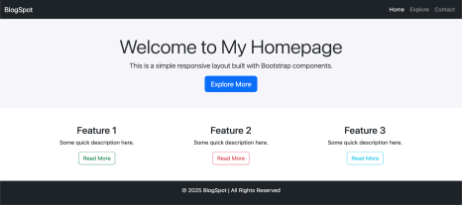

Experiment No.: 2

Title: Design a Grid-Based Information Page Using Bootstrap

Aim: To design and develop a grid-based information page using Bootstrap’s Grid System, displaying multiple content items such as cards, product previews, or blog entries with consistent alignment and spacing.

Objectives:
- To understand and apply Bootstrap’s Grid System for creating multi-column layouts.
- To design a structured page layout suitable for displaying multiple information items.
- To use Bootstrap components such as cards for presenting content neatly.
- To ensure consistent alignment, spacing, and responsiveness across all devices.

Theory:
The Bootstrap Grid System is a powerful layout tool based on a 12-column structure that enables developers to create responsive, organized page designs. It divides the page into rows and columns that automatically adjust to the device’s screen size.
Key components:
- Container: Wraps the content and provides responsive padding and alignment.
- Row: Creates horizontal groups of columns to organize content.
- Column Classes (col-sm, col-md, col-lg, etc.): Define how many columns an element spans across different device sizes.
- Cards: Pre-styled Bootstrap components used to display grouped content such as product previews, user profiles, or blog entries.
By combining these, developers can create well-aligned, multi-column layouts where elements maintain consistent spacing and alignment even when resized.

Conclusion:
A grid-based information page was successfully designed using Bootstrap’s Grid System and components such as cards. The layout displayed multiple items with proper spacing and alignment, adapting effectively to different screen sizes. This experiment demonstrated the use of Bootstrap’s responsive grid to create clean, organized, and professional web layouts suitable for information or product display pages.
CODE:-
<!doctype html>
<html lang="en">
<head>
<meta charset="utf-8">
<meta name="viewport" content="width=device-width, initial-scale=1">
<title>Grid Based Info Page — Bootstrap</title>
<!-- Bootstrap 5 CDN -->
<link href="https://cdn.jsdelivr.net/npm/bootstrap@5.3.2/dist/css/bootstrap.min.css"
rel="stylesheet">
<style>
.card-img-top {
height: 160px;
object-fit: cover;
}
.card.h-100 { display: flex; flex-direction: column; }
.card-body { flex: 1 1 auto; }
.meta { font-size: .85rem; color: #6c757d; }
.card-hover:hover { transform: translateY(-6px); box-shadow: 0 10px 20px rgba(0,0,0,.08); }
.card-hover { transition: transform .18s ease, box-shadow .18s ease; }
.sticky-sidebar { position: sticky; top: 1rem; }
.empty-state { min-height: 220px; display:flex; align-items:center; justify-content:center;
color:#6c757d; }
</style>
</head>
<body>
<!-- Header -->
<header class="bg-light py-3 mb-4">
<div class="container">
<div class="d-flex align-items-center justify-content-between">
<h1 class="h4 mb-0">Discover</h1>

<div>
<button class="btn btn-outline-primary btn-sm me-2">Sign in</button>
<button class="btn btn-primary btn-sm">Subscribe</button>
</div>
</div>
<p class="text-muted mb-0">A responsive, grid-based information layout for cards, products or
blog entries.</p>
</div>
</header>
<!-- Main -->
<main class="container">
<div class="row">
<!-- Sidebar -->
<aside class="col-12 col-md-3 mb-4">
<div class="card p-3 sticky-sidebar">
<h5 class="mb-3">Filters</h5>
<div class="mb-2">
<label class="form-label small mb-1">Category</label>
<select id="filterCategory" class="form-select form-select-sm">
<option value="all">All</option>
<option value="product">Products</option>
<option value="blog">Blog</option>
<option value="case">Case Studies</option>
</select>
</div>
<div class="mb-2">
<label class="form-label small mb-1">Sort</label>
<select id="sortBy" class="form-select form-select-sm">
<option value="newest">Newest</option>
<option value="popular">Most popular</option>
</select>
</div>
<hr>
<div class="d-grid">
<button id="applyFilters" class="btn btn-sm btn-primary">Apply</button>
</div>
</div>
</aside>
<!-- Grid Section -->
<section class="col-12 col-md-9">

<div class="d-flex align-items-center justify-content-between mb-3">
<h2 class="h5 mb-0">All Items</h2>
<small class="text-muted">Showing <span id="shownCount">6</span> items</small>
</div>
<div id="itemsGrid" class="row row-cols-1 row-cols-sm-2 row-cols-md-3 row-cols-lg-4 g-4">
<!-- Example Cards -->
<article class="col" data-cat="product">
<div class="card h-100 card-hover">
<img src="https://picsum.photos/seed/p1/640/360" class="card-img-top" alt="Product">
<div class="card-body">
<h3 class="h6">Compact Coffee Grinder</h3>
<p class="text-truncate">High-precision burr grinder, perfect for espresso and pour-over.</p>
<span class="badge bg-success">In stock</span>
<span class="meta ms-2">$49.99</span>
</div>
</div>
</article>
<article class="col" data-cat="blog">
<div class="card h-100 card-hover">
<img src="https://picsum.photos/seed/b1/640/360" class="card-img-top" alt="Blog">
<div class="card-body">
<h3 class="h6">How to tune your grinder</h3>
<p class="text-truncate">Step-by-step guide to better extraction and flavor clarity.</p>
<span class="badge bg-secondary">Guide</span>
<span class="meta ms-2">6 min read</span>
</div>
</div>
</article>
<article class="col" data-cat="case">
<div class="card h-100 card-hover">
<img src="https://picsum.photos/seed/c1/640/360" class="card-img-top" alt="Case Study">
<div class="card-body">
<h3 class="h6">Cafe Growth Case Study</h3>
<p class="text-truncate">How a coffee shop scaled with automation and UX.</p>
<span class="badge bg-info text-dark">Case</span>
</div>
</div>
</article>

<!-- Duplicate cards for demo -->
<article class="col" data-cat="product">
<div class="card h-100 card-hover">
<img src="https://picsum.photos/seed/p2/640/360" class="card-img-top" alt="Product">
<div class="card-body">
<h3 class="h6">Thermal Travel Mug</h3>
<p class="text-truncate">Keeps drinks hot for 8 hours, leak-proof lid.</p>
<span class="badge bg-warning text-dark">Limited</span>
<span class="meta ms-2">$19.99</span>
</div>
</div>
</article>
<article class="col" data-cat="blog">
<div class="card h-100 card-hover">
<img src="https://picsum.photos/seed/b2/640/360" class="card-img-top" alt="Blog">
<div class="card-body">
<h3 class="h6">Brew Methods Compared</h3>
<p class="text-truncate">A comparison of pour-over, French press and Aeropress.</p>
<span class="badge bg-secondary">Article</span>
<span class="meta ms-2">9 min read</span>
</div>
</div>
</article>
<article class="col" data-cat="product">
<div class="card h-100 card-hover">
<img src="https://picsum.photos/seed/p3/640/360" class="card-img-top" alt="Product">
<div class="card-body">
<h3 class="h6">Single-Serve Dripper</h3>
<p class="text-truncate">Lightweight ceramic dripper for consistent extraction.</p>
<span class="badge bg-success">In stock</span>
<span class="meta ms-2">$9.99</span>
</div>
</div>
</article>
</div>
</section>
</div>
</main>
<!-- Footer -->

<footer class="bg-light py-4 mt-5">
<div class="container text-center">
<small class="text-muted">© 2025 Grid Info — Demo layout using Bootstrap</small>
</div>
</footer>
<!-- JS -->
<script
src="https://cdn.jsdelivr.net/npm/bootstrap@5.3.2/dist/js/bootstrap.bundle.min.js"></script>
<script>
(function(){
const grid = document.getElementById('itemsGrid');
const items = Array.from(grid.querySelectorAll('[data-cat]'));
const filter = document.getElementById('filterCategory');
const apply = document.getElementById('applyFilters');
const count = document.getElementById('shownCount');
function applyFilter(){
const cat = filter.value;
let shown = 0;
items.forEach(i=>{
const c = i.getAttribute('data-cat');
const match = (cat === 'all') || (c === cat);
i.style.display = match ? '' : 'none';
if(match) shown++;
});
count.textContent = shown;
}
apply.addEventListener('click', applyFilter);
applyFilter();
})();
</script>
</body>
</html>
OUTPUT:-
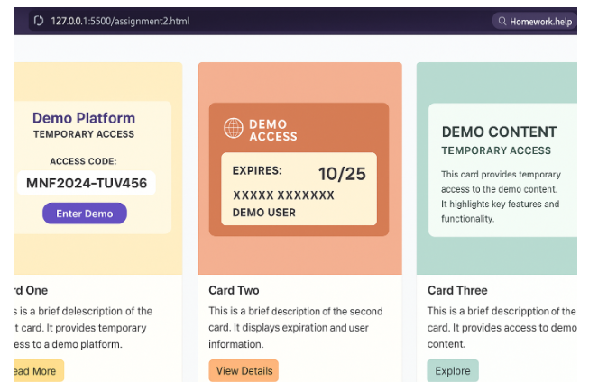

Experiment No.: 3
Title: Set Up a Node.js Project with Express Server

Aim: To initialize a Node.js project and create a basic Express.js web server with multiple routes such as Home (/), About (/about), and Contact (/contact).

Objectives:
- To set up a Node.js project using the npm init command.
- To install and configure Express.js, a web framework for Node.js.
- To create and run a basic web server capable of handling multiple routes.
- To understand how to respond to HTTP requests using Express.

Theory:
Node.js is a JavaScript runtime environment that allows developers to execute JavaScript code on the server side. It uses an event-driven, non-blocking I/O model, making it efficient for building scalable web applications.
Express.js is a minimal and flexible Node.js framework that simplifies the creation of web servers and APIs. It provides tools for handling routes, middleware, and HTTP requests.
Key concepts:
- npm init: Initializes a new Node.js project and creates a package.json file that stores project metadata and dependencies.
- Express.js: Installed using npm install express, it allows defining routes and handling client requests with methods like app.get() and app.listen().
- Routing: Defines how the application responds to various client requests (e.g., /, /about, /contact).
- Server: The Express app listens on a specific port (e.g., 3000) and sends back responses for each route.
By combining Node.js and Express, developers can build efficient and modular back-end applications quickly.
Conclusion:
A Node.js project was successfully initialized and configured with Express.js. The basic web server handled multiple routes such as Home, About, and Contact, returning appropriate responses for each. This experiment demonstrated how Express simplifies server creation and routing, providing a foundation for building dynamic web applications.
CODE:-
// server.js
const express = require("express");
const app = express();
const PORT = 3000;
// Home route
app.get("/", (req, res) => {
res.send("Welcome to the Home Page!");
});
// About route
app.get("/about", (req, res) => {
res.send("This is the About Page.");
});
// Contact route
app.get("/contact", (req, res) => {
res.send("Contact us at: pranaypatel176@gmail.com");
});
// Start the server
app.listen(PORT, () => {
console.log(`Server is running at http://localhost:${PORT}`);

OUTPUT:-

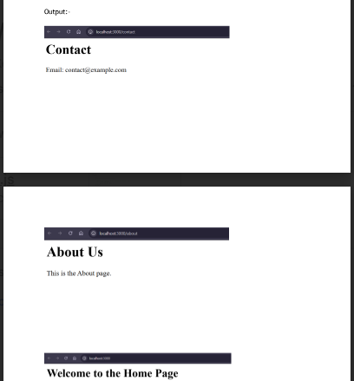

Experiment No.: 4

Title: Implement Modular Routing and Middleware Logging in Express.js

Aim: To implement modular routing in an Express.js application and create a middleware function to log request URLs, HTTP methods, and timestamps for all incoming traffic.

Objectives:
- To understand and apply the concept of modular routing in Express.js by separating routes into different modules (e.g., userRoutes, productRoutes).
- To implement a custom middleware that logs each request’s details such as URL, method, and timestamp.
- To improve the structure, readability, and maintainability of Express server code.
- To observe how middleware functions process requests before they reach route handlers.

Theory:
In Express.js, a web application is structured around routes and middleware.
- Routing: Defines how the application responds to client requests at different endpoints (paths) and HTTP methods. To make large applications more organized, routes can be modularized — defined in separate files and imported into the main server file. For example, userRoutes.js might handle all routes related to users, and productRoutes.js might handle product-related routes.
- Middleware: Middleware functions are pieces of code that execute before the final request handler. They can modify the request and response objects or perform tasks like authentication, validation, or logging.
- A logging middleware can capture useful information such as:
    - Request URL (req.url)
    - HTTP Method (req.method)
    - Timestamp (using new Date())
- Modular Design: Helps in code reusability, clarity, and scalability of large applications by separating concerns between different functionalities.

Conclusion:
A Node.js application using Express.js was successfully implemented with modular routing and a custom middleware for logging request details. The middleware captured URLs, methods, and timestamps for every incoming request, while the modular route structure improved code organization and readability. This experiment demonstrated the importance of middleware and modularization in building scalable and maintainable Express applications.
CODE:-
Route.js-
const express = require('express');
const app = express();
const port = 4000;
const usersRouter = require('./users');
const productsRouter = require('./products');
app.use('/users', usersRouter);
app.use('/products', productsRouter);
app.get('/', (req, res) => {
res.send(`
<h1>Express Bees</h1>
<ul>
<li><a href="/users">Users</a></li>
<li><a href="/products">Products</a></li>
</ul>
`);
});
app.listen(port, () => {
console.log(`Server running at http://localhost:${port}`);
});

Users.js-
const express = require('express');
const router = express.Router();
let users = [
{ id: 1, name: 'Sunil', email: 'sunil@microsoftteams.com' },
{ id: 1, name: 'Mahesh', email: 'mahesh@microsoftteams.com' }
];
router.use((req, res, next) => {
console.log('Users Router Time:', Date.now());
next();
});
router.get('/', (req, res) => {
let list = users.map(u => `<li><a href="/users/${u.id}">${u.name}</a></li>`).join('');
res.send(`
<h2>Users List</h2>
<ul>${list}</ul>
<form method="POST" action="/users">
<input type="text" name="name" placeholder="Enter name" required />
<input type="email" name="email" placeholder="Enter email" required />
<button type="submit">Add User</button>
</form>
`);
});
router.get('/:id', (req, res) => {
const user = users.find(u => u.id == req.params.id);
if (!user) return res.send('User not found');
res.send(`
<h2>User Profile</h2>
<p>ID: ${user.id}</p>
<p>Name: ${user.name}</p>
<p>Email: ${user.email}</p>
<p><a href="/users">Back to list</a></p>
`);
});
router.post('/', express.urlencoded({ extended: true }), (req, res) => {
const newUser = {
id: users.length + 1,
name: req.body.name,
email: req.body.email
};
users.push(newUser);
res.redirect('/users');
});
module.exports = router;

Products.js-
const express = require('express');
const router = express.Router();
let products = [
{ id: 1, name: 'Laptop', price: 50000 },
{ id: 2, name: 'Phone', price: 20000 }
];
router.get('/', (req, res) => {
let list = products.map(p => `<li><a href="/products/${p.id}">${p.name}</a></li>`).join('');
res.send(`
<h2>Products List</h2>
<ul>${list}</ul>
<form method="POST" action="/products">
<input type="text" name="name" placeholder="Product name" required />
<input type="number" name="price" placeholder="Price" required />
<button type="submit">Add Product</button>
</form>
`);
});
router.get('/:id', (req, res) => {
const product = products.find(p => p.id == req.params.id);
if (!product) return res.send('Product not found');
res.send(`
<h2>Product Details</h2>
<p>ID: ${product.id}</p>
<p>Name: ${product.name}</p>
<p>Price: ₹${product.price}</p>
<p><a href="/products">Back to list</a></p>
`);
});
router.post('/', express.urlencoded({ extended: true }), (req, res) => {
const newProduct = {
id: products.length + 1,
name: req.body.name,
price: req.body.price
};
products.push(newProduct);
res.redirect('/products');
});
module.exports = router;

OUTPUT:-
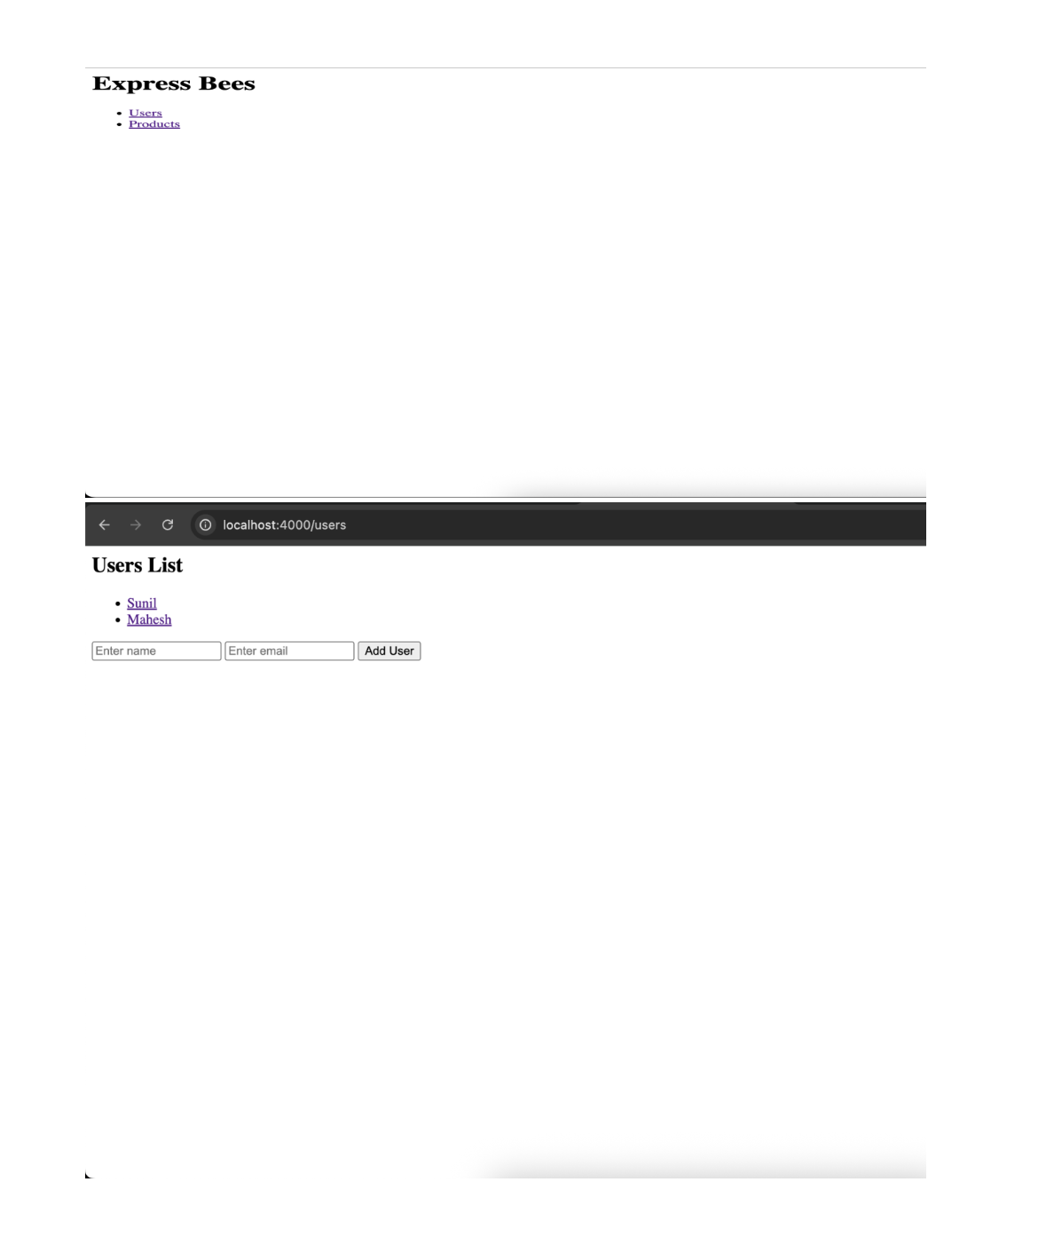
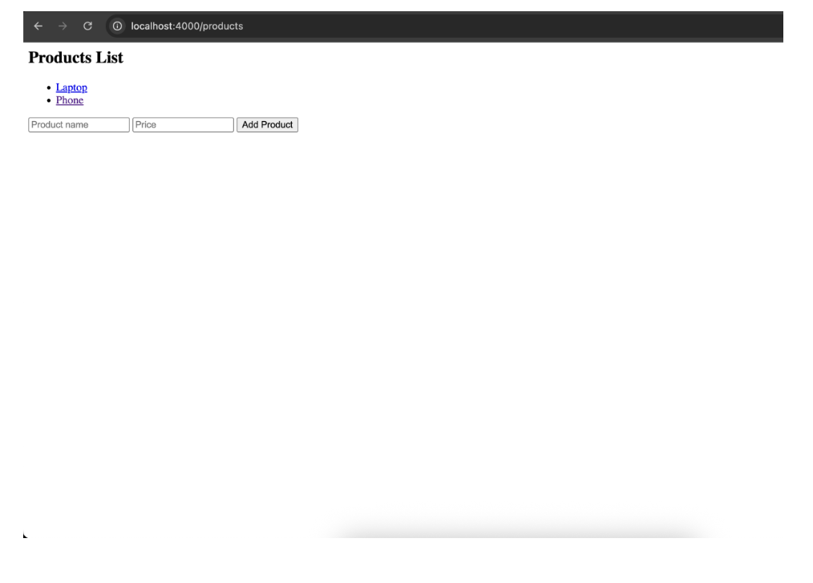

Experiment No.: 5

Title: Create a Data Submission Form and Handle POST Requests Using Express.js

Aim: To design and implement an HTML form for data submission and handle its POST request using Express.js, displaying the submitted data dynamically on a confirmation view.

Objectives:

- To create an HTML form that allows users to submit information (e.g., item details or feedback).
- To configure Express.js to handle POST requests from the form.
- To use body-parsing middleware (like express.urlencoded) to process submitted form data.
- To dynamically display the submitted data on a confirmation page after successful submission.

Theory:
In web development, forms are the primary means for collecting user input. When a form is submitted, the data can be sent to the server using either the GET or POST method.
- GET Method: Sends data via the URL; suitable for small, non-sensitive data.
- POST Method: Sends data in the request body; more secure and commonly used for form submissions.
Express.js simplifies handling of form submissions by using middleware like:
- express.urlencoded({ extended: true }): Parses incoming form data from the request body.
- req.body: Accesses the submitted data on the server side.
Typical workflow:
- A user fills out and submits the form.
- The server receives the POST request and extracts data using req.body.
- The server sends a response view displaying the submitted data dynamically.
This process demonstrates how back-end logic interacts with front-end input, forming the basis for data-driven web applications.
Conclusion:
An HTML data submission form was successfully created and connected to an Express.js server for handling POST requests. The submitted data was processed on the server and displayed dynamically on a confirmation view. This experiment illustrated the flow of user input from the client to the server and back, emphasizing the importance of POST handling and data rendering in interactive web applications.

CODE:-

APP.js
const express = require("express");
const bodyParser = require("body-parser");
const app = express();

// Middleware setup
app.set("view engine", "ejs");
app.use(bodyParser.urlencoded({ extended: true }));
app.use(express.static("public"));

// Routes
app.get("/", (req, res) => {
res.render("form"); // render the HTML form page
});

app.post("/submit", (req, res) => {
// Get data from the form submission
const { name, email, feedback } = req.body;

// Pass data to confirmation view
res.render("confirmation", { name, email, feedback });
});

// Start the server
const PORT = 3030;
app.listen(PORT, () => {
console.log(`Server running on http://localhost:${PORT}`);
});

Form.ejs
<!DOCTYPE html>
<html lang="en">
<head>
<meta charset="UTF-8">
<title>Feedback Form</title>
</head>
<body>
<h1>Submit Your Feedback</h1>
<form action="/submit" method="POST">
<label for="name">Name:</label><br>
<input type="text" name="name" id="name" required><br><br>

<label for="email">Email:</label><br>
<input type="email" name="email" id="email" required><br><br>

<label for="feedback">Feedback:</label><br>
<textarea name="feedback" id="feedback" rows="5" required></textarea><br><br>

<button type="submit">Submit</button>
</form>
</body>
</html>

Confirmation.ejs

<!DOCTYPE html>
<html lang="en">
<head>
<meta charset="UTF-8">
<title>Submission Confirmation</title>
</head>
<body>
<h1>Thank You, <%= name %>!</h1>
<p>Your feedback has been received.</p>
<h3>Submission Details:</h3>
<ul>
<li><strong>Name:</strong> <%= name %></li>
<li><strong>Email:</strong> <%= email %></li>
<li><strong>Feedback:</strong> <%= feedback %></li>
</ul>

<a href="/">Submit Another Response</a>
</body>
</html>

OUTPUT:-
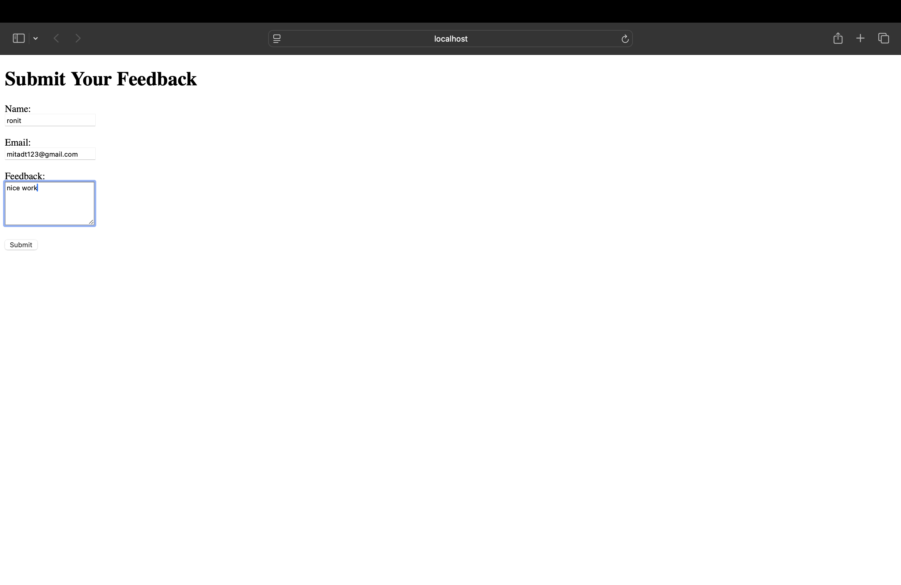

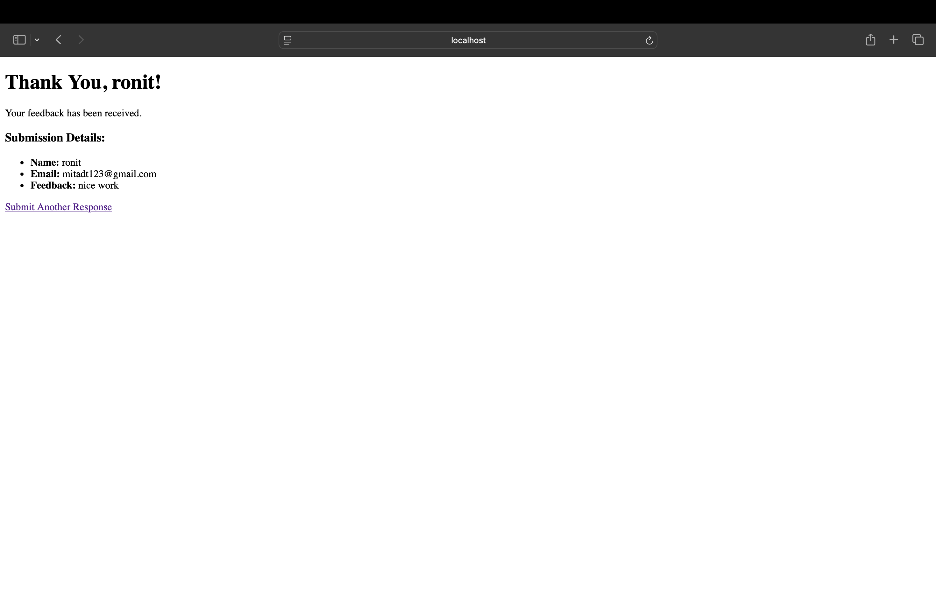

Experiment No.: 6

Title: Serve Dynamic Content Using Server-Side Rendering with EJS

Aim: To render dynamic web content on the server side using EJS (Embedded JavaScript Templates) in an Express.js application, displaying a list of items (e.g., products, posts, or services) using in-memory data.

Objectives:
- To configure EJS as the view engine in an Express.js application.
- To create routes that send data from the server to the EJS templates.
- To render a dynamic list of items (e.g., products or posts) using loops in the EJS view.
- To understand how server-side rendering (SSR) works to generate HTML before sending it to the client.
Theory:
Server-Side Rendering (SSR) is the process of generating HTML content on the server before delivering it to the client’s browser. Instead of sending plain data (like JSON), the server sends fully rendered HTML pages.
EJS (Embedded JavaScript) is a templating engine for Node.js that allows developers to embed JavaScript code directly within HTML files. It works seamlessly with Express.js to display dynamic content.
Key concepts:
- View Engine Setup:
Express can be configured to use EJS by setting app.set('view engine', 'ejs').
- Passing Data to Views:
Data can be passed from the route handler to the EJS file using res.render('template', { data }).
- Dynamic Rendering:
Inside EJS templates, loops like <% items.forEach(item => { %> ... <% }) %> can render multiple elements dynamically based on server-provided data.
Using EJS allows the creation of dynamic, server-rendered pages that adapt based on the content or user interactions.
Conclusion:
A dynamic content rendering system was successfully implemented using EJS with Express.js. The application displayed a list of items (e.g., products or posts) rendered on the server using in-memory data and EJS looping constructs. This experiment demonstrated the fundamentals of server-side rendering, where content is generated dynamically before being sent to the client, improving efficiency and SEO compatibility.
CODE:-
APP.js
const express = require("express");
const app = express();

// Set up EJS as the template engine
app.set("view engine", "ejs");

// In-memory data
const products = [
{ id: 1, name: "Laptop", price: 1200, description: "A powerful laptop for professionals." },
{ id: 2, name: "Headphones", price: 150, description: "Noise-cancelling over-ear headphones." },
{ id: 3, name: "Keyboard", price: 70, description: "Mechanical keyboard with RGB lights." },
{ id: 4, name: "Mouse", price: 40, description: "Wireless ergonomic mouse." },
];

// Default route — redirect to /products
app.get("/", (req, res) => {
res.redirect("/products");
});

// Route to render product list
app.get("/products", (req, res) => {
res.render("products", { products });
});

// Start the server
const PORT = 3000;
app.listen(PORT, () => {
console.log(`✅ Server running at http://localhost:${PORT}`);
});

Products.ejs
<!DOCTYPE html>
<html lang="en">
<head>
<meta charset="UTF-8">
<title>Product List</title>
<style>
body { font-family: Arial, sans-serif; margin: 40px; background-color: #f9f9f9; }
h1 { color: #333; }
.product {
background: #fff;
border: 1px solid #ddd;
border-radius: 8px;
padding: 15px;
margin: 15px 0;
box-shadow: 0 2px 4px rgba(0,0,0,0.1);
}
</style>
</head>
<body>
<h1>Available Products</h1>

<% if (products.length > 0) { %>
<% products.forEach(product => { %>
<div class="product">
<h2><%= product.name %></h2>
<p><strong>Price:</strong> $<%= product.price %></p>
<p><%= product.description %></p>
</div>
<% }) %>
<% } else { %>
<p>No products available.</p>
<% } %>
</body>
</html>

OUTPUT:-
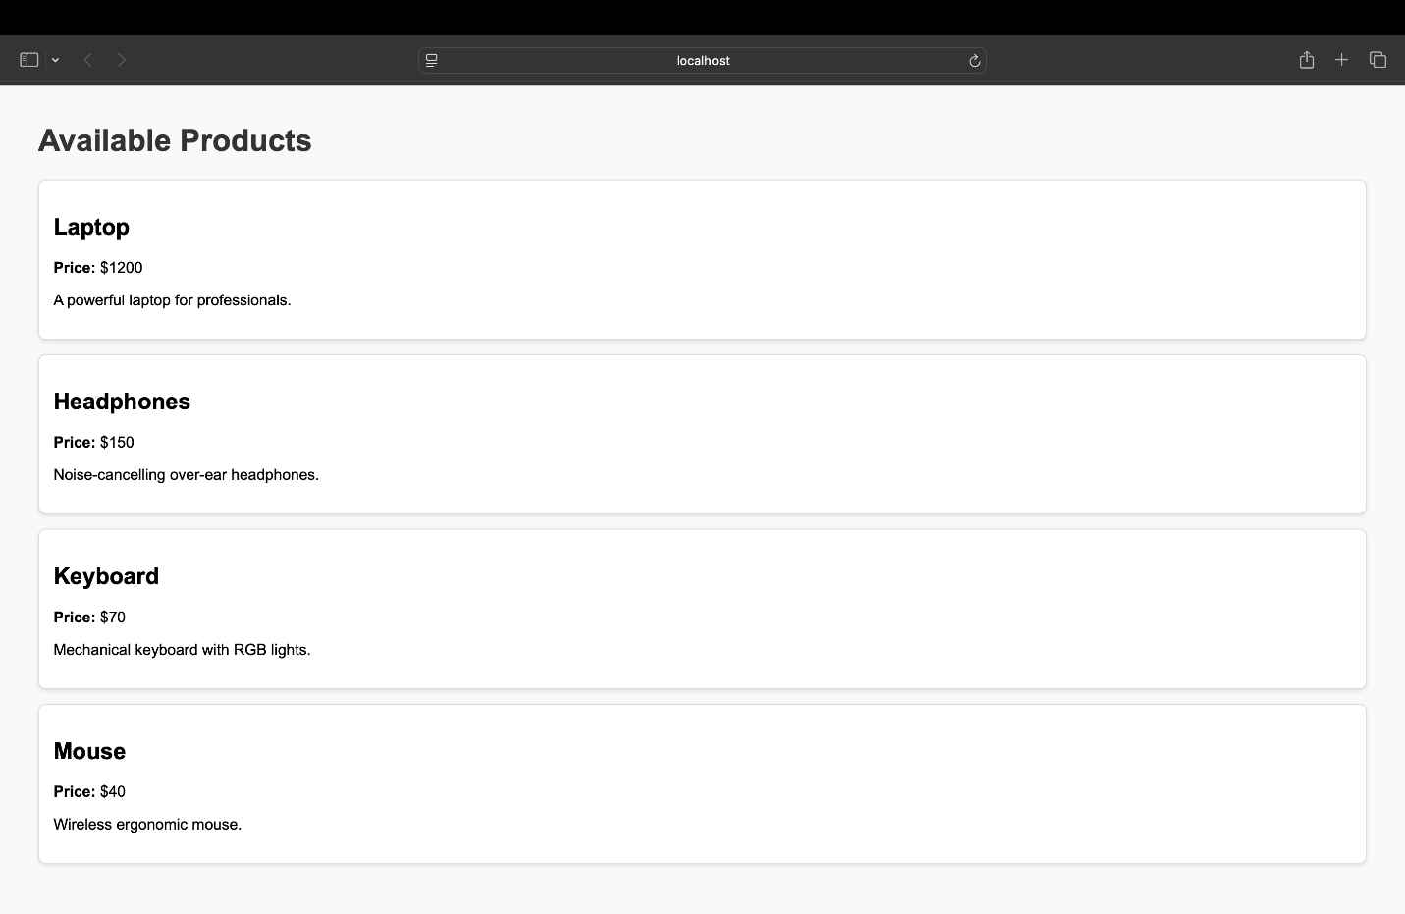

Experiment No.: 7

Title: Create Dynamic Detail Pages Using URL Parameters in Express.js with EJS

Aim: To create dynamic web pages that display individual item details using route parameters in Express.js, rendering the data dynamically in EJS templates.

Objectives:
- To understand and implement route parameters in Express.js routes.
- To pass dynamic data (e.g., title, description, date) to EJS templates based on the route parameter.
- To render individual detail pages dynamically using EJS views.
- To simulate item data using hardcoded or in-memory objects for demonstration.
Theory:
Route parameters allow Express.js routes to capture dynamic values from the URL and use them to generate specific responses. They are defined in routes using a colon (:) before a variable name (e.g., /items/:id).
Key concepts:
- Route Parameters:
Express automatically parses parameters in the URL. The value can be accessed through req.params.
Example:
app.get('/items/:id', (req, res) => {
const itemId = req.params.id;
});
- Data Retrieval:
The route parameter can be used to look up an item’s data from an array or object stored in memory (e.g., a list of products or posts).
- Dynamic Rendering with EJS:
Once the specific item is found, the data is passed to the EJS view using res.render('itemDetail', { item }), and the view dynamically displays properties like title, description, and date.
This approach is commonly used in blogs, product catalogs, or user profiles — where each item has its own unique detail page.

Conclusion:
A dynamic detail page system was successfully implemented using Express.js route parameters and EJS templates. The application displayed unique content for each item by extracting the item’s ID from the URL and rendering its details dynamically. This experiment demonstrated how route parameters enable flexible and dynamic page generation in server-side applications.
CODE:-
App.js
const express = require("express");
const app = express();

app.set("view engine", "ejs");

// Temporary in-memory data
const products = [
{ id: 1, title: "Laptop", description: "A powerful laptop for professionals.", date: "2025-11-03" },
{ id: 2, title: "Headphones", description: "Noise-cancelling over-ear headphones.", date: "2025-10-15" },
{ id: 3, title: "Keyboard", description: "Mechanical keyboard with RGB lights.", date: "2025-09-25" },
{ id: 4, title: "Mouse", description: "Wireless ergonomic mouse.", date: "2025-08-10" },
];

// Route to show list of products
app.get("/products", (req, res) => {
res.render("products", { products });
});

// Route to show a single product’s details using route parameter (:id)
app.get("/products/:id", (req, res) => {
const productId = parseInt(req.params.id);
const product = products.find(p => p.id === productId);

if (!product) {
return res.status(404).send("Product not found!");
}

res.render("product-detail", { product });
});

// Redirect root to products
app.get("/", (req, res) => res.redirect("/products"));

// Start server
const PORT = 3000;
app.listen(PORT, () => {
console.log(`✅ Server running at http://localhost:${PORT}`);
});
Product.ejs
<!DOCTYPE html>
<html lang="en">
<head>
<meta charset="UTF-8">
<title>Product List</title>
<style>
body { font-family: Arial, sans-serif; margin: 40px; }
h1 { color: #333; }
.product {
border: 1px solid #ccc;
border-radius: 8px;
padding: 15px;
margin: 15px 0;
background-color: #f9f9f9;
}
</style>
</head>
<body>
<h1>Available Products</h1>

<% if (products.length > 0) { %>
<% products.forEach(product => { %>
<div class="product">
<h2><%= product.title %></h2>
<p><%= product.description %></p>
<a href="/products/<%= product.id %>">View Details</a>
</div>
<% }) %>
<% } else { %>
<p>No products available.</p>
<% } %>
</body>
</html>

Product-detail.ejs

<!DOCTYPE html>
<html lang="en">
<head>
<meta charset="UTF-8">
<title><%= product.title %> - Details</title>
<style>
body { font-family: Arial, sans-serif; margin: 40px; }
.container { max-width: 600px; margin: 0 auto; }
.back-link { margin-top: 20px; display: inline-block; }
</style>
</head>
<body>
<div class="container">
<h1><%= product.title %></h1>
<p><strong>Description:</strong> <%= product.description %></p>
<p><strong>Date Added:</strong> <%= product.date %></p>

<a href="/products" class="back-link">← Back to Products</a>
</div>
</body>
</html>

OUTPUT: -
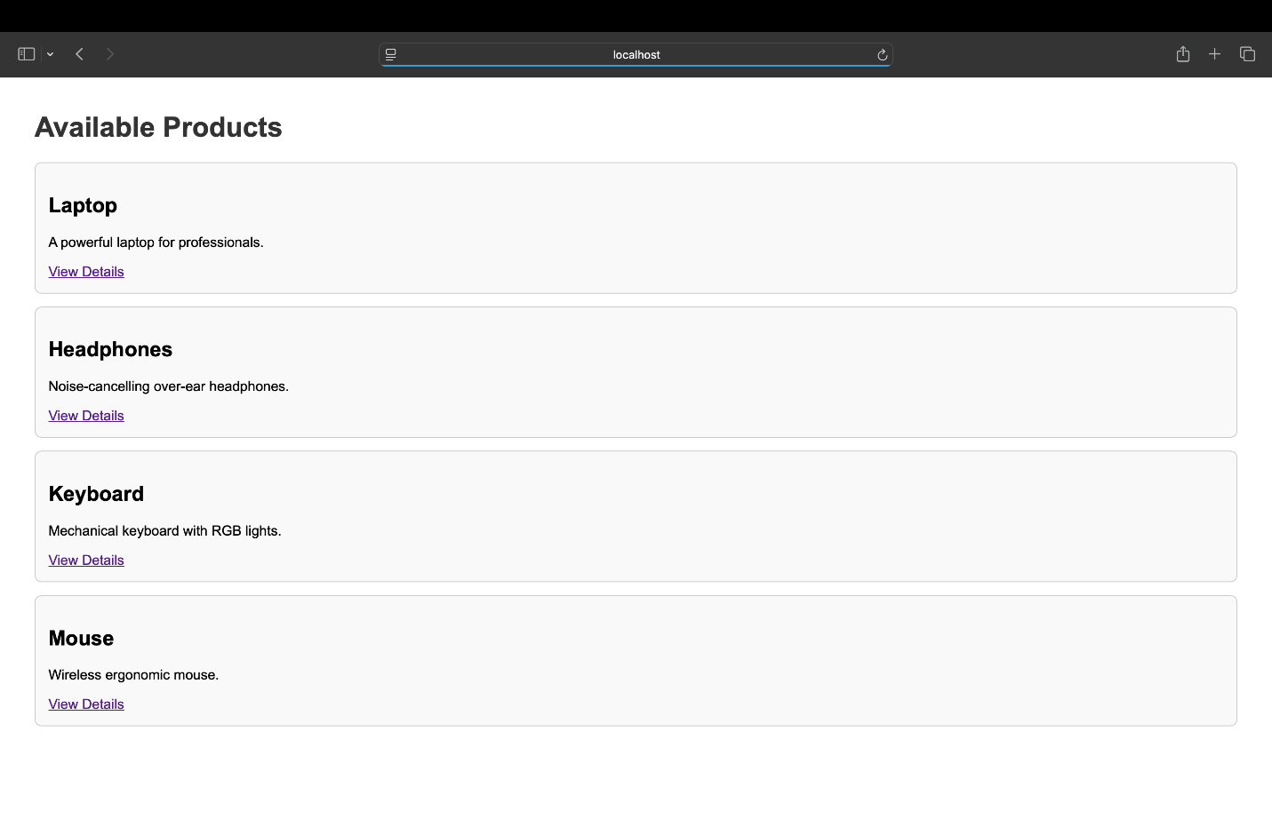

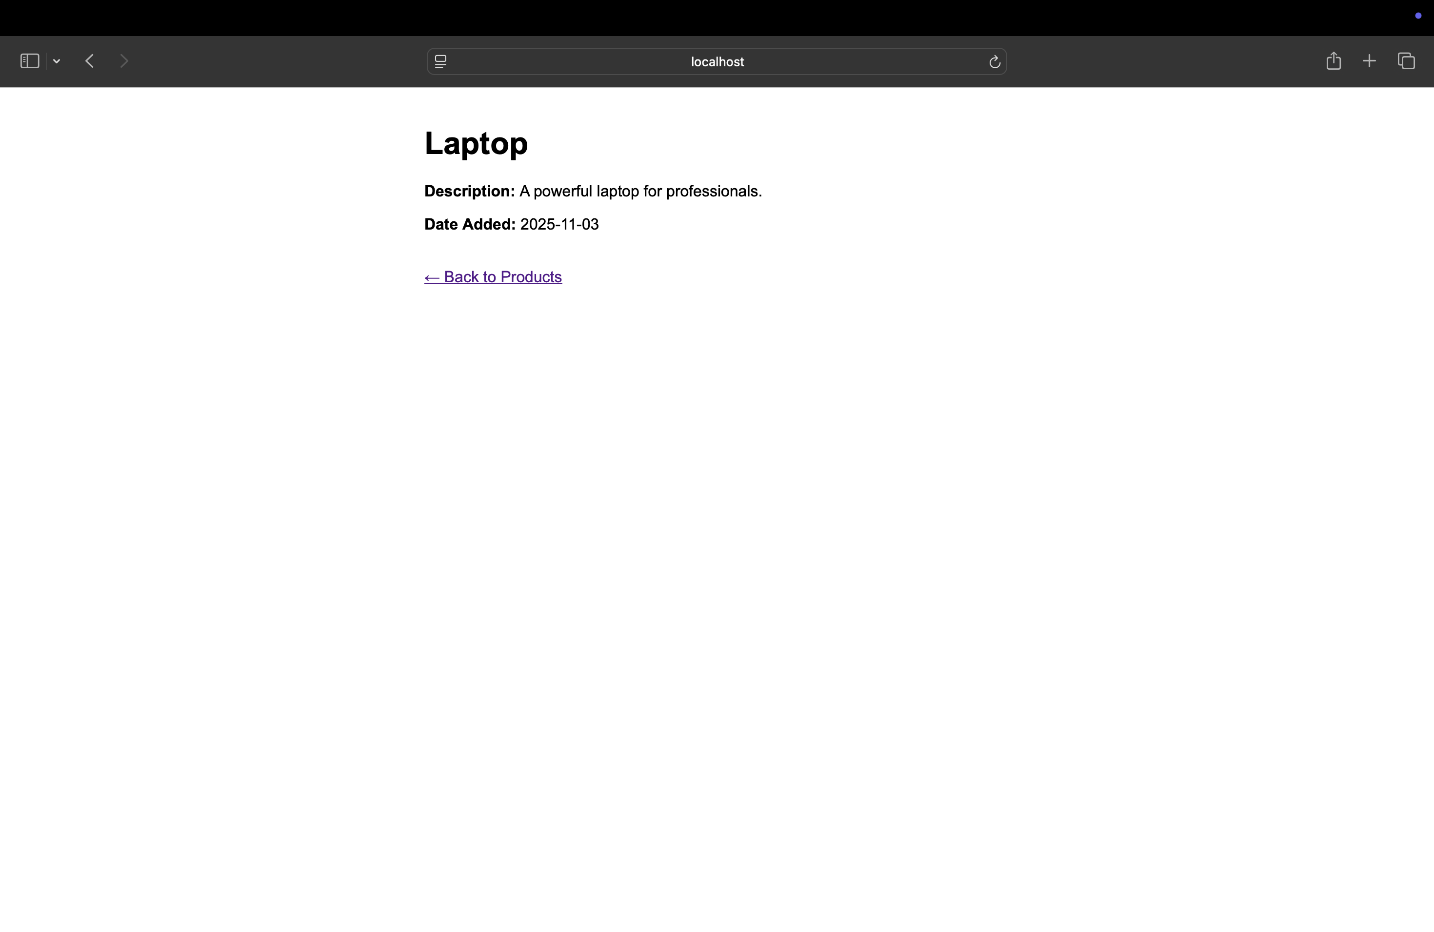

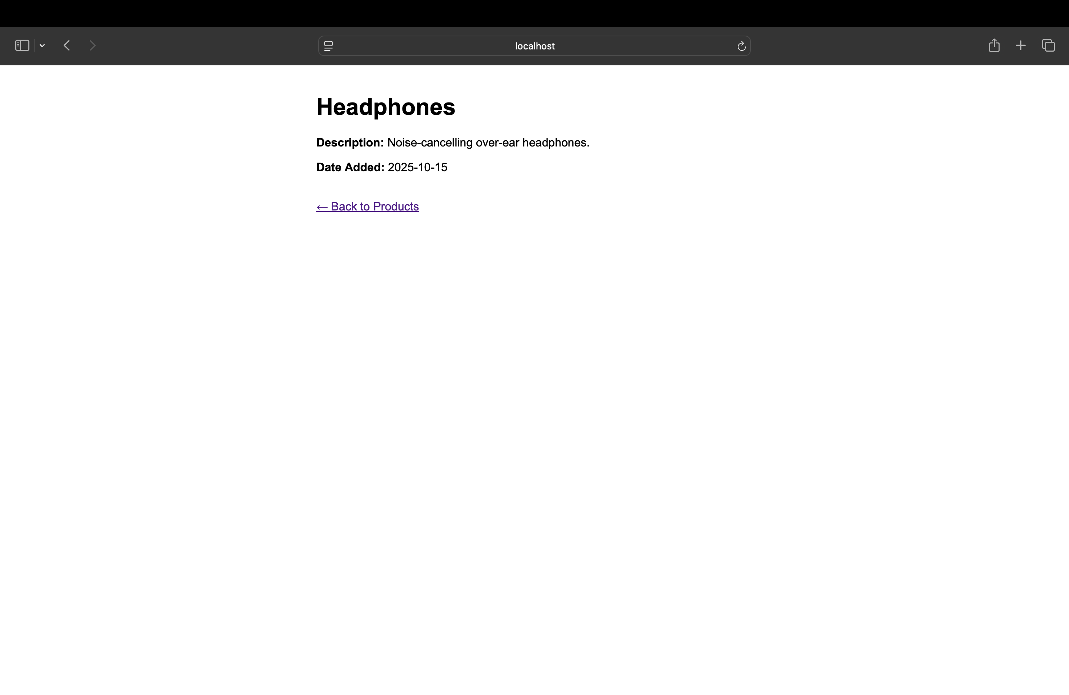

Experiment No.: 8

Title: Build a Reusable Layout Using EJS Partials

Aim:To create and implement reusable layout components using EJS partials (such as header, footer, and navbar) and include them across multiple views to maintain design consistency.

Objectives:
- To understand the concept of EJS partials and their role in reusable web design.
- To create common layout components like header, footer, and navigation bar.
- To include partials across different EJS templates using the EJS <%- include() %> directive.
- To maintain a consistent structure and style across all pages in the application.

Theory:
In web development, maintaining consistent design elements (like headers, footers, or navigation bars) across multiple pages is important for both user experience and code efficiency.
EJS partials allow developers to modularize repeating sections of HTML and include them in multiple templates, similar to how functions reuse code in programming.

Key concepts:
- Partials:
Partials are small EJS files (e.g., _header.ejs, _footer.ejs, _navbar.ejs) containing reusable UI sections.
- Including Partials:
The <%- include('partials/filename') %> directive is used to insert a partial into a template.
- Layout Consistency:
By using partials, any update made to a shared component automatically reflects across all pages where it’s included.
- Modular Design:
This approach simplifies maintenance, enhances scalability, and reduces code repetition.
Example inclusion:
<%- include('partials/header') %>
<main>
<h1>Welcome to the Homepage</h1>
</main>
<%- include('partials/footer') %>

Conclusion:
A reusable layout system was successfully developed using EJS partials for the header, footer, and navigation bar. These partials were included across multiple views, ensuring uniform structure and easy maintenance. This experiment demonstrated how EJS partials support modular and consistent web design, improving both development efficiency and page organization.

CODE:-

App.js
const express = require("express");
const app = express();

app.set("view engine", "ejs");

// Temporary in-memory data
const products = [
{ id: 1, title: "Laptop", description: "A powerful laptop for professionals.", date: "2025-11-03" },
{ id: 2, title: "Headphones", description: "Noise-cancelling over-ear headphones.", date: "2025-10-15" },
{ id: 3, title: "Keyboard", description: "Mechanical keyboard with RGB lights.", date: "2025-09-25" },
{ id: 4, title: "Mouse", description: "Wireless ergonomic mouse.", date: "2025-08-10" },
];

// Route to show list of products
app.get("/products", (req, res) => {
res.render("products", { products });
});

// Route to show a single product’s details using route parameter (:id)
app.get("/products/:id", (req, res) => {
const productId = parseInt(req.params.id);
const product = products.find(p => p.id === productId);

if (!product) {
return res.status(404).send("Product not found!");
}

res.render("product-detail", { product });
});

// Redirect root to products
app.get("/", (req, res) => res.redirect("/products"));

// Start server
const PORT = 3030;
app.listen(PORT, () => {
console.log(`✅ Server running at http://localhost:${PORT}`);
});

Header.ejs
<!DOCTYPE html>
<html lang="en">
<head>
<meta charset="UTF-8">
<title><%= title || "My EJS App" %></title>
<style>
body { font-family: Arial, sans-serif; margin: 0; background: #f9f9f9; }
header, footer { background: #333; color: white; padding: 15px; text-align: center; }
nav a {
color: white;
text-decoration: none;
margin: 0 10px;
font-weight: bold;
}
nav a:hover { text-decoration: underline; }
.container { padding: 20px; }
</style>
</head>
<body>
<header>
<h1><%= title || "Welcome" %></h1>
<%- include("navbar") %> <!-- ✅ Correct include path -->
</header>
<div class="container">

Navbar.ejs
<nav>
<a href="/">Home</a>
<a href="/products">Products</a>
<a href="/about">About</a>
</nav>

Footer.ejs
</div> <!-- End container -->
<footer>
<p>&copy; 2025 My EJS App. All rights reserved.</p>
</footer>
</body>
</html>

Products.ejs
<%- include("partials/header", { title: "Products" }) %>

<h2>Available Products</h2>

<% if (products.length > 0) { %>
<% products.forEach(product => { %>
<div style="background: #fff; border: 1px solid #ddd; padding: 15px; border-radius: 8px; margin: 15px 0;">
<h3><%= product.title %></h3>
<p><%= product.description %></p>
<a href="/products/<%= product.id %>">View Details</a>
</div>
<% }) %>
<% } else { %>
<p>No products available.</p>
<% } %>

<%- include("partials/footer") %>

Product-detail.ejs
<%- include("partials/header", { title: product.title }) %>

<h2><%= product.title %></h2>
<p><strong>Description:</strong> <%= product.description %></p>
<p><strong>Date Added:</strong> <%= product.date %></p>

<a href="/products">← Back to Products</a>

<%- include("partials/footer") %>

OUTPUT:-
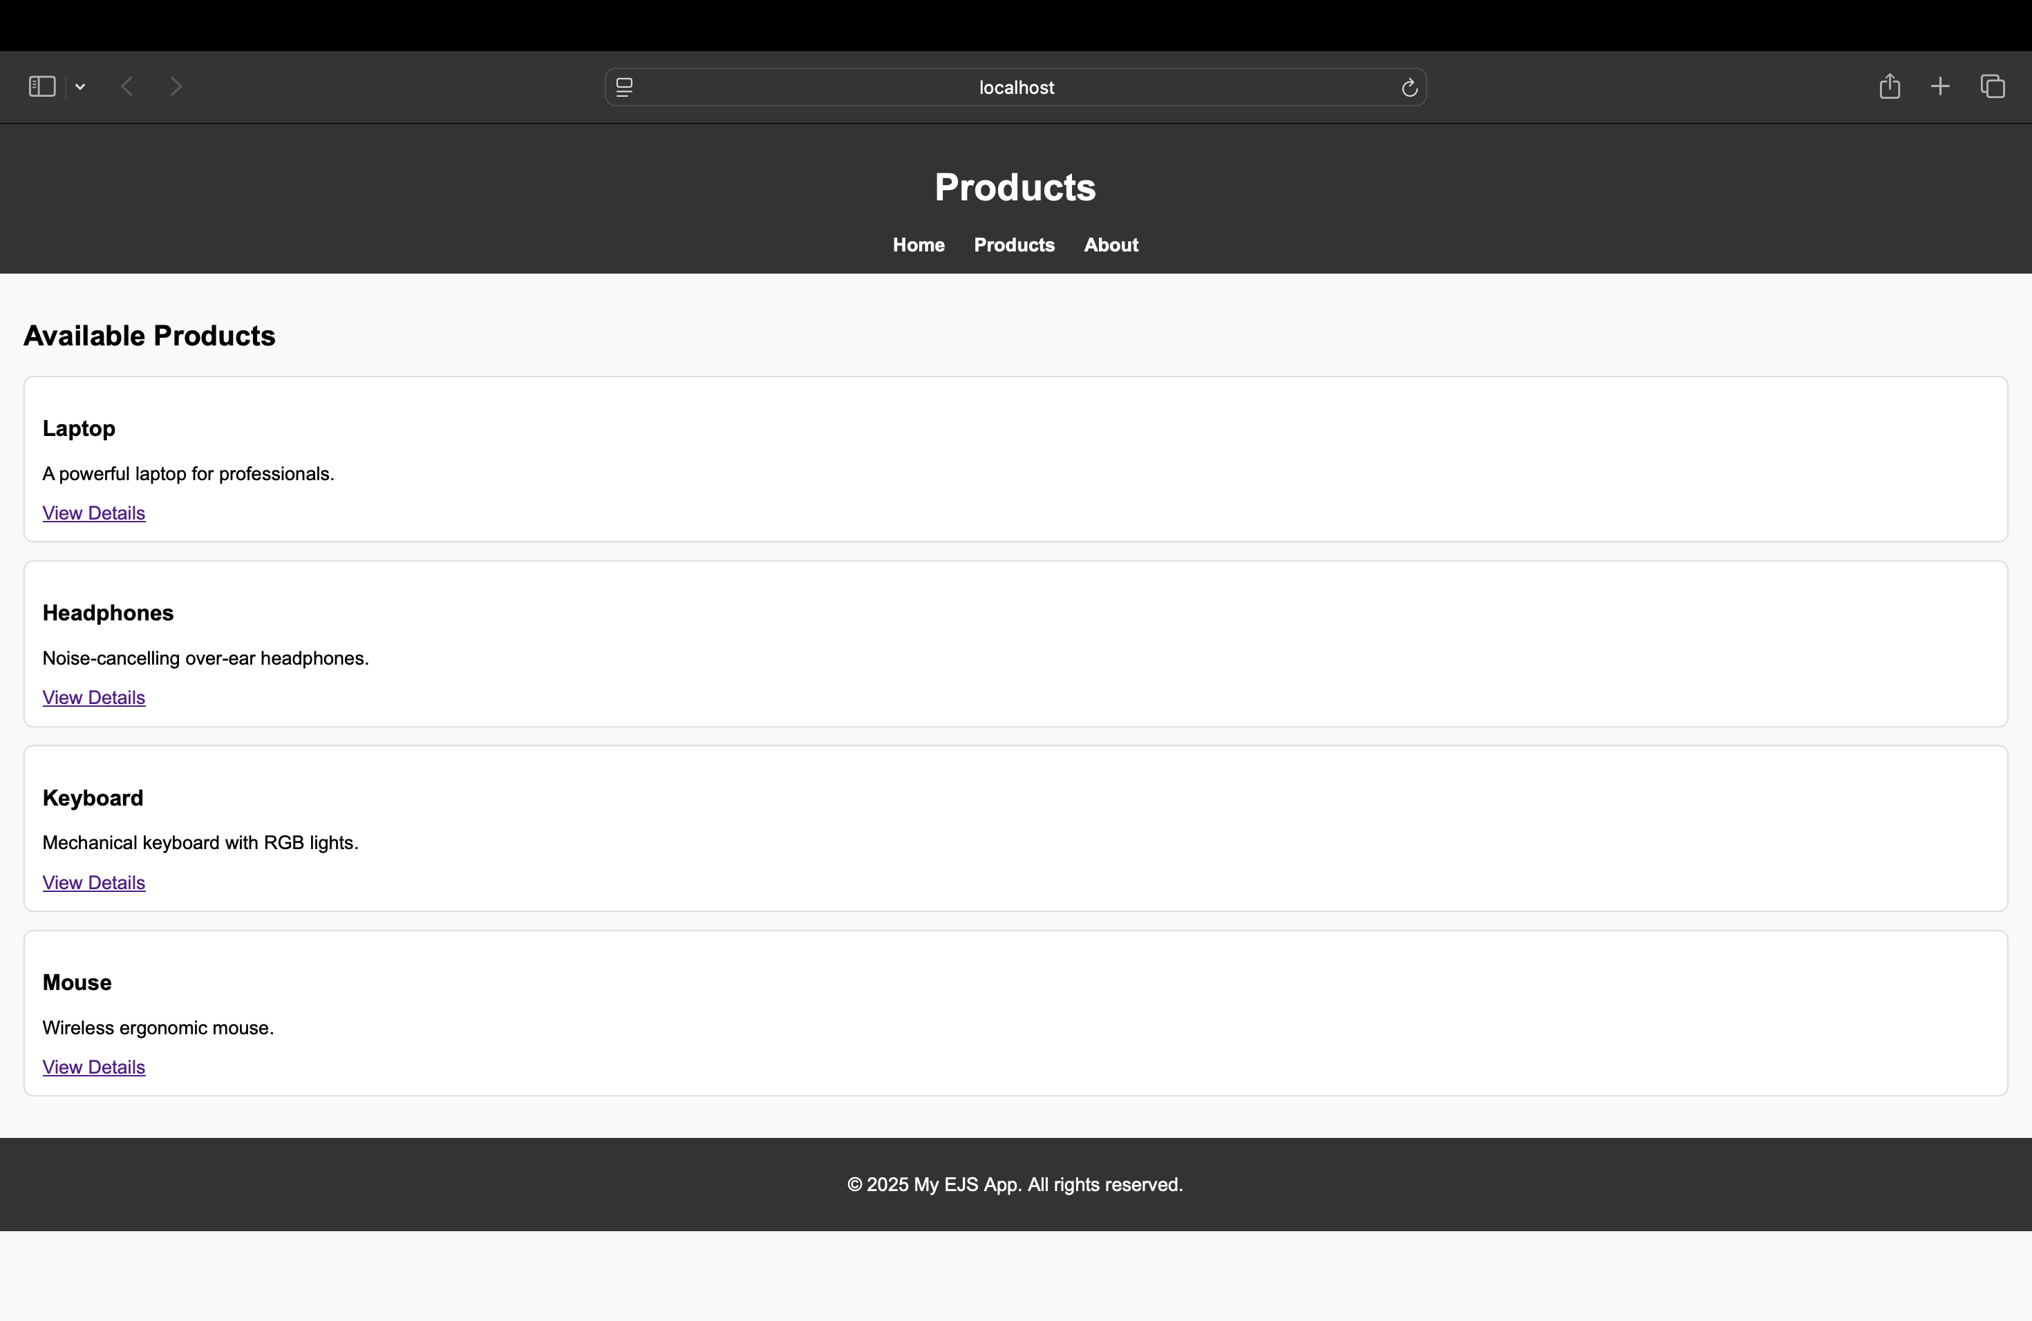

Experiment No.: 9

Title: Connect Node.js to MySQL and Perform Basic CRUD Operations

Aim: To establish a connection between Node.js and MySQL using a MySQL Node.js package, and to implement basic CRUD (Create, Read, Update, Delete) operations through Express.js routes.
Objectives:
- To create and configure a MySQL database and table for data storage.
- To connect the Node.js application to the MySQL database using the mysql2 or mysql package.
- To implement CRUD operations via Express routes:
  - Create: Insert new records.
  - Read: Retrieve and display records.
  - Update: Modify existing records.
  - Delete: Remove records from the table.
- To understand how Express routes interact with a relational database for persistent data management.

Theory:
MySQL is an open-source relational database management system (RDBMS) that stores data in structured tables connected by relationships.
Node.js can connect to MySQL databases using libraries such as mysql or mysql2, enabling web applications to interact with persistent data through SQL queries.
Key concepts:
- Database Connection:
The connection is established using credentials such as host, user, password, and database name.
Example:
const mysql = require('mysql2');
const db = mysql.createConnection({
host: 'localhost',
user: 'root',
password: '',
database: 'sampledb'
});
db.connect(err => {
if (err) throw err;
console.log('Connected to MySQL');
});
- CRUD Operations:
  - Create: INSERT INTO table_name (...) VALUES (...);
  - Read: SELECT * FROM table_name;
  - Update: UPDATE table_name SET column=value WHERE id=?;
  - Delete: DELETE FROM table_name WHERE id=?;
- Integration with Express:
Each CRUD action can be handled through different routes (POST, GET, PUT, DELETE), allowing users to interact with the database from the web interface.
This combination of Node.js and MySQL forms the backbone of many modern full-stack web applications, allowing for dynamic, data-driven functionality.

Conclusion:

A Node.js–MySQL connection was successfully established using the MySQL package, and basic CRUD operations were implemented through Express routes. Data could be created, viewed, updated, and deleted directly from the web interface, confirming proper interaction between the Node.js server and the MySQL database. This experiment demonstrated how server-side logic integrates with relational databases to enable dynamic, persistent web applications.

CODE:-
App.js
const express = require("express");
const bodyParser = require("body-parser");
const mysql = require("mysql2");
const app = express();

app.set("view engine", "ejs");
app.use(bodyParser.urlencoded({ extended: true }));

// MySQL Connection
const db = mysql.createConnection({
host: "localhost",
user: "root", // your MySQL username
password: "", // your MySQL password (if any)
database: "node_crud" // the database you created
});

db.connect(err => {
if (err) throw err;
console.log("✅ Connected to MySQL database.");
});

// ---------------- ROUTES ---------------- //

// READ: Show all products
app.get("/products", (req, res) => {
const sql = "SELECT * FROM products";
db.query(sql, (err, results) => {
if (err) throw err;
res.render("products", { products: results });
});
});

// CREATE: Show form
app.get("/add", (req, res) => {
res.render("add-product");
});

// CREATE: Handle form submission
app.post("/add", (req, res) => {
const { title, description, price } = req.body;
const sql = "INSERT INTO products (title, description, price) VALUES (?, ?, ?)";
db.query(sql, [title, description, price], (err) => {
if (err) throw err;
res.redirect("/products");
});
});

// UPDATE: Show edit form
app.get("/edit/:id", (req, res) => {
const sql = "SELECT * FROM products WHERE id = ?";
db.query(sql, [req.params.id], (err, results) => {
if (err) throw err;
res.render("edit-product", { product: results[0] });
});
});

// UPDATE: Handle edit form submission
app.post("/edit/:id", (req, res) => {
const { title, description, price } = req.body;
const sql = "UPDATE products SET title=?, description=?, price=? WHERE id=?";
db.query(sql, [title, description, price, req.params.id], (err) => {
if (err) throw err;
res.redirect("/products");
});
});

// DELETE: Delete a product
app.get("/delete/:id", (req, res) => {
const sql = "DELETE FROM products WHERE id = ?";
db.query(sql, [req.params.id], (err) => {
if (err) throw err;
res.redirect("/products");
});
});

// Redirect root
app.get("/", (req, res) => res.redirect("/products"));

// Start server
const PORT = 3030;
app.listen(PORT, () => {
console.log(`🚀 Server running on http://localhost:${PORT}`);
});

Products.ejs
<!DOCTYPE html>
<html>
<head>
<title>Product List</title>
</head>
<body>
<h1>Product List</h1>
<a href="/add">➕ Add New Product</a>
<table border="1" cellpadding="8">
<tr>
<th>ID</th><th>Title</th><th>Description</th><th>Price</th><th>Actions</th>
</tr>
<% products.forEach(product => { %>
<tr>
<td><%= product.id %></td>
<td><%= product.title %></td>
<td><%= product.description %></td>
<td>$<%= product.price %></td>
<td>
<a href="/edit/<%= product.id %>">✏️ Edit</a> |
<a href="/delete/<%= product.id %>" onclick="return confirm('Delete this item?')">🗑️ Delete</a>
</td>
</tr>
<% }) %>
</table>
</body>
</html>

Add product.ejs
<!DOCTYPE html>
<html>
<head>
<title>Add Product</title>
</head>
<body>
<h1>Add New Product</h1>
<form method="POST" action="/add">
<label>Title:</label><br>
<input type="text" name="title" required><br><br>

<label>Description:</label><br>
<textarea name="description" required></textarea><br><br>

<label>Price:</label><br>
<input type="number" name="price" step="0.01" required><br><br>

<button type="submit">Add Product</button>
</form>
<br>
<a href="/products">← Back to List</a>
</body>
</html>

Edit-product.ejs
<!DOCTYPE html>
<html>
<head>
<title>Edit Product</title>
</head>
<body>
<h1>Edit Product</h1>
<form method="POST" action="/edit/<%= product.id %>">
<label>Title:</label><br>
<input type="text" name="title" value="<%= product.title %>" required><br><br>

<label>Description:</label><br>
<textarea name="description" required><%= product.description %></textarea><br><br>

<label>Price:</label><br>
<input type="number" name="price" step="0.01" value="<%= product.price %>" required><br><br>

<button type="submit">Update Product</button>
</form>
<br>
<a href="/products">← Back to List</a>
</body>
</html>
OUTPUT:-
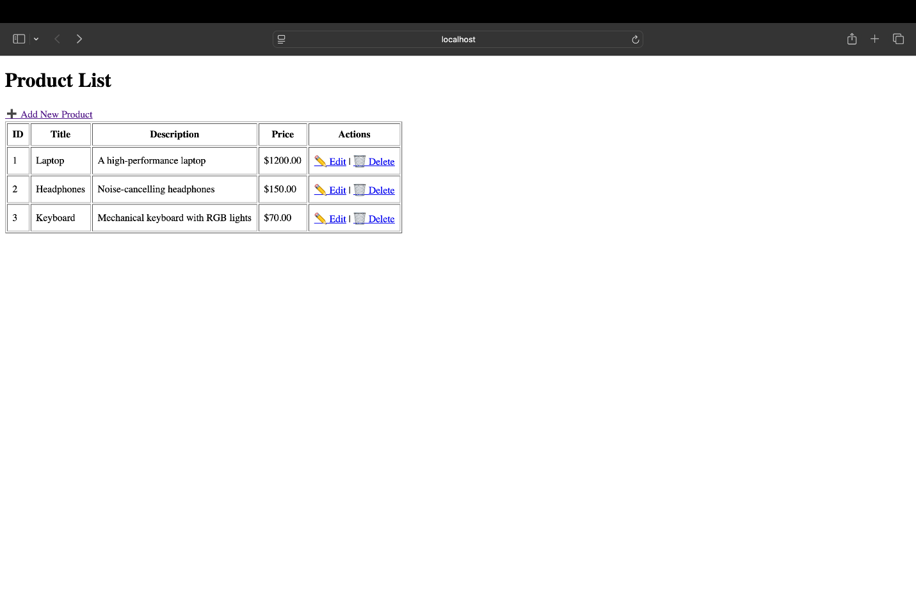
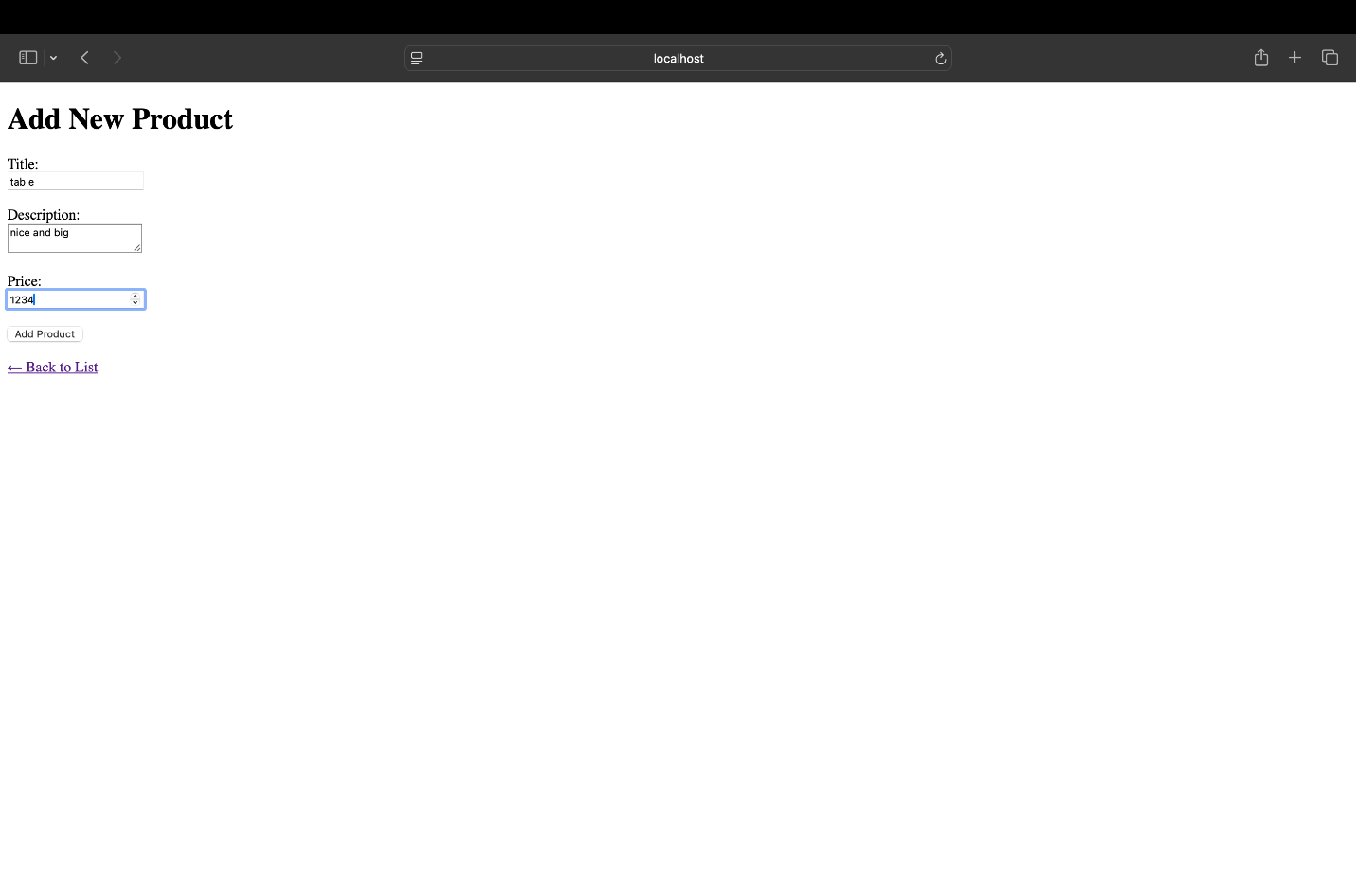

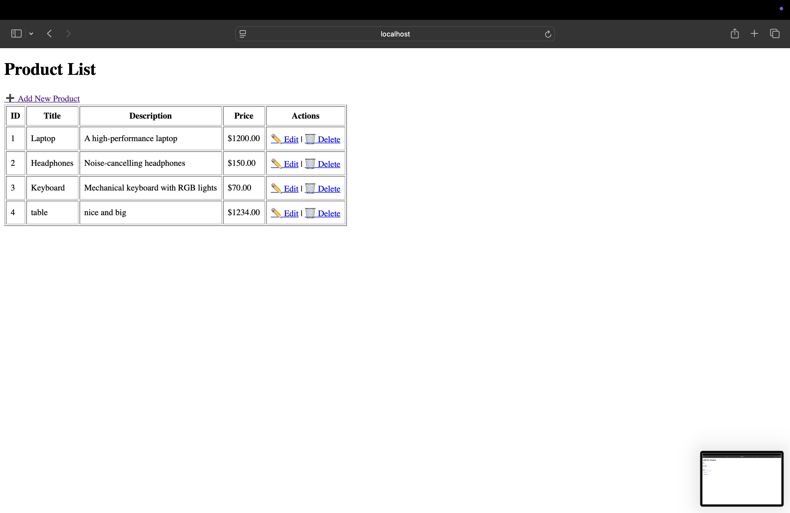

Experiment No.: 10
Title: Develop RESTful APIs for Data Access and Manipulation Using Express.js.

Aim:To design and implement a set of RESTful APIs using Express.js that perform CRUD operations for data access and manipulation, and to test these endpoints using Postman for proper JSON responses.

Objectives:
- To understand the concept and principles of RESTful API design.
- To create multiple API endpoints (GET, POST, PUT, DELETE) using Express.js.
- To handle JSON data requests and responses effectively.
- To test and validate API functionality using Postman.
Theory:
A RESTful API (Representational State Transfer) is an architectural style for designing web services that communicate using standard HTTP methods. Each endpoint (or route) represents a specific resource, and actions are performed using HTTP methods.
Key HTTP Methods:
- GET: Retrieve data from the server.
- POST: Add new data to the server.
- PUT: Update existing data on the server.
- DELETE: Remove data from the server.
Principles of REST:
- Stateless: Each request from a client contains all information needed to process it.
- Resource-Based URLs: Endpoints represent resources, e.g., /api/users, /api/products.
- JSON Data Exchange: Data is typically sent and received in JSON format for simplicity and interoperability.
Implementation Steps:
- Create an Express.js server and define API routes.
- Use express.json() middleware to parse JSON request bodies.
- Implement CRUD routes using appropriate HTTP methods.
- Test endpoints in Postman by sending requests and checking JSON responses.
Example Route Structure:
app.get('/api/items', (req, res) => { ... }); // Read
app.post('/api/items', (req, res) => { ... }); // Create
app.put('/api/items/:id', (req, res) => { ... }); // Update
app.delete('/api/items/:id', (req, res) => { ... }); // Delete
Testing with Postman helps verify that each endpoint returns the correct status codes (200, 201, 404, etc.) and structured JSON responses.
Conclusion:
A set of RESTful APIs was successfully developed using Express.js to handle data access and manipulation operations. Each endpoint responded with well-structured JSON data and was verified using Postman. This experiment demonstrated the fundamentals of RESTful API design and validation, forming the basis for scalable, modular, and data-driven web applications.

CODE:-
App.js
const express = require("express");
const bodyParser = require("body-parser");
const db = require("./db/connection");

const app = express();
const PORT = 4000;

// Middleware
app.use(bodyParser.json());

// ✅ Root route
app.get("/", (req, res) => {
res.send("Welcome to the Product API! Use /api/products to access data.");
});

// ✅ Get all products
app.get("/api/products", (req, res) => {
const sql = "SELECT * FROM products";
db.query(sql, (err, results) => {
if (err) return res.status(500).json({ error: err.message });
res.json(results);
});
});

// ✅ Get a product by ID
app.get("/api/products/:id", (req, res) => {
const sql = "SELECT * FROM products WHERE id = ?";
db.query(sql, [req.params.id], (err, results) => {
if (err) return res.status(500).json({ error: err.message });
if (results.length === 0) return res.status(404).json({ message: "Product not found" });
res.json(results[0]);
});
});

// ✅ Add a new product
app.post("/api/products", (req, res) => {
const { title, description, price } = req.body;
if (!title || !description || !price) {
return res.status(400).json({ error: "All fields (title, description, price) are required." });
}
const sql = "INSERT INTO products (title, description, price) VALUES (?, ?, ?)";
db.query(sql, [title, description, price], (err, result) => {
if (err) return res.status(500).json({ error: err.message });
res.status(201).json({ message: "Product added successfully", productId: result.insertId });
});
});

// ✅ Update a product
app.put("/api/products/:id", (req, res) => {
const { title, description, price } = req.body;
const sql = "UPDATE products SET title=?, description=?, price=? WHERE id=?";
db.query(sql, [title, description, price, req.params.id], (err, result) => {
if (err) return res.status(500).json({ error: err.message });
if (result.affectedRows === 0) return res.status(404).json({ message: "Product not found" });
res.json({ message: "Product updated successfully" });
});
});

// ✅ Delete a product
app.delete("/api/products/:id", (req, res) => {
const sql = "DELETE FROM products WHERE id = ?";
db.query(sql, [req.params.id], (err, result) => {
if (err) return res.status(500).json({ error: err.message });
if (result.affectedRows === 0) return res.status(404).json({ message: "Product not found" });
res.json({ message: "Product deleted successfully" });
});
});

// Start the server
app.listen(PORT, () => {
console.log(`🚀 Server running at http://localhost:${PORT}`);
});

Connection.js
const mysql = require("mysql2");

// MySQL connection setup
const db = mysql.createConnection({
host: "localhost",
user: "root", // your MySQL username
password: "", // your MySQL password (if any)
database: "node_crud" // your database name
});

// connect
db.connect((err) => {
if (err) {
console.error("❌ MySQL connection failed:", err);
} else {
console.log("✅ Connected to MySQL database.");
}
});

module.exports = db;

OUTPUT:-
